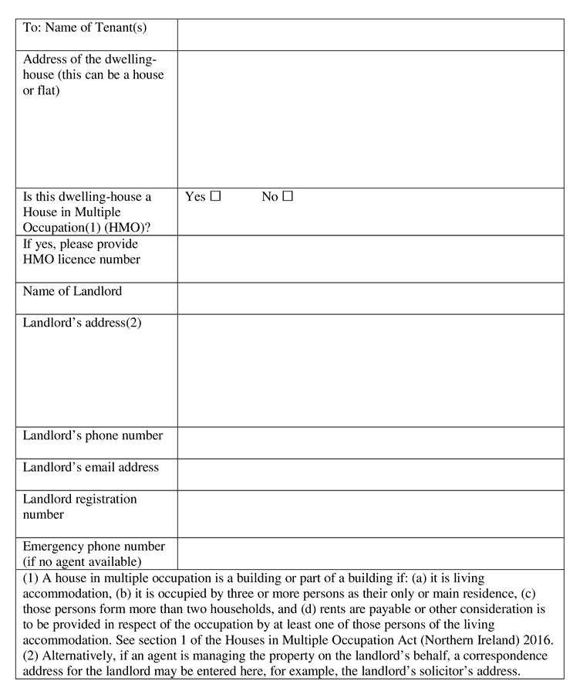
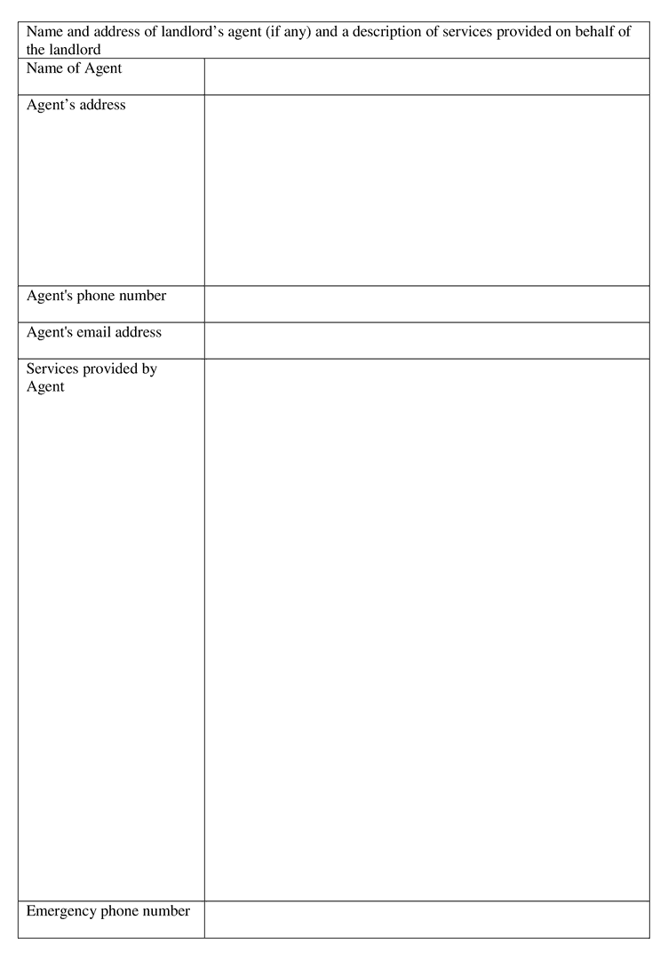
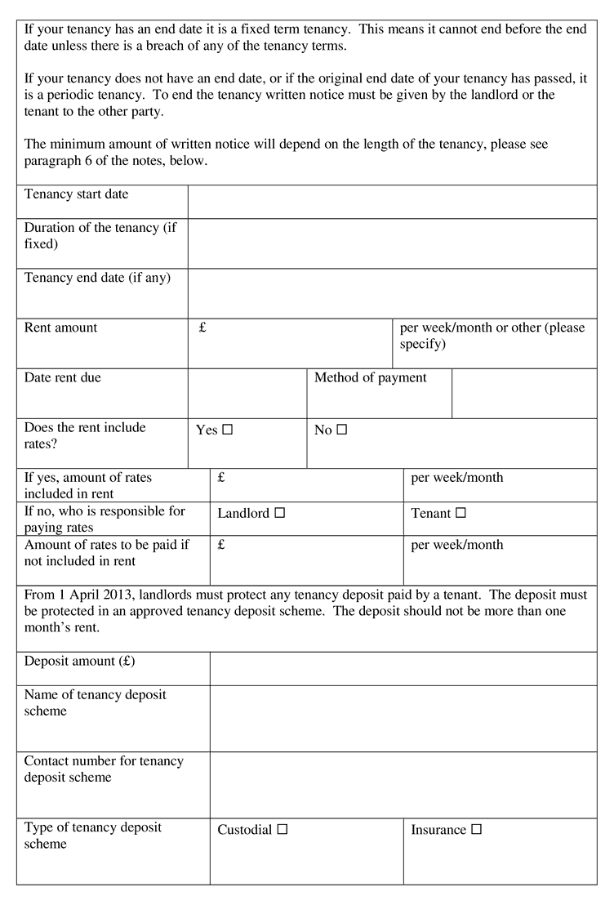
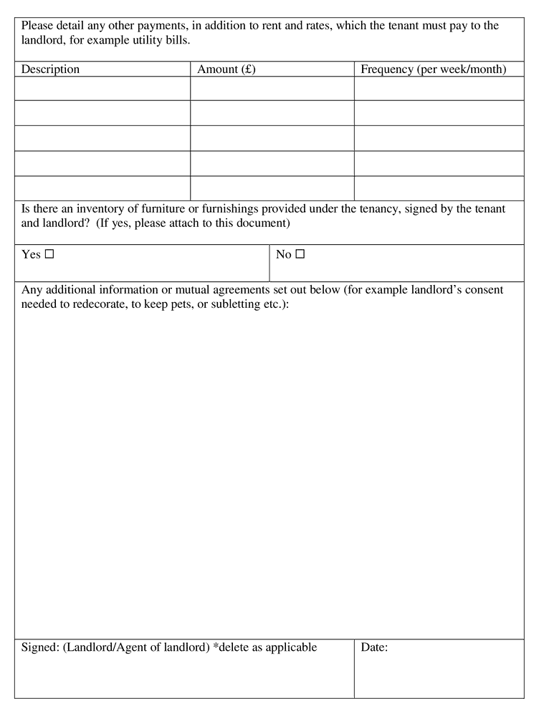

NOTES

General
1. Your tenancy is not a protected or statutory tenancy within the meaning of the Rent (Northern Ireland) Order 1978 as amended by Article 56 of the Private Tenancies (Northern Ireland) Order 2006. You have the protection of the legal rights described below. However, other terms and conditions of your tenancy are a matter for you and your landlord.
Commencement Information
I1Sch. 1(crossheading)(notes paragraph)(1n1) in operation at 1.4.2023, see reg. 1(1)

Repairs
2. Your landlord is obliged to keep in repair all gas fittings, flues and installations. Your landlord must also provide you with a copy of the required safety checks in relation to gas appliances and flues. In some circumstances, your landlord may also display a copy of any safety certificate prominently in the property. Responsibility for other repairs is determined by your tenancy agreement. You can get help from the environmental health department of your local council if repairs are not carried out. See Appendix 1 (below) for more information.
Commencement Information
I2Sch. 1 para. 2 in operation at 1.4.2023, see reg. 1(1)

Access for repairs
3. By law, you must let your landlord (or their representatives or contractors) have reasonable access to the property to carry out repairs or an inspection. Your landlord should give you reasonable notice before this happens.
Commencement Information
I3Sch. 1 para. 3 in operation at 1.4.2023, see reg. 1(1)

Fitness for human habitation
4. Your landlord is responsible for ensuring your property is safe. If:
- Your property was built before 1945, and
- Your tenancy began on or after 2007, and
- The property is not a prescribed dwelling-house, and
- It has no current certificate of fitness then, you can ask your local council to inspect it to ensure it is fit for human habitation.
Where a rented property does not meet the fitness standard, it is subject to rent control through the Rent Officer for Northern Ireland.
Commencement Information
I4Sch. 1 para. 4 in operation at 1.4.2023, see reg. 1(1)

Receipts
5. All private tenants have a legal right to a receipt for any cash payment in relation to their tenancy. The receipt should detail:
- The amount paid,
- The date it was paid,
- What the payment was for,
- If an amount remains outstanding, the amount, or
- If payment was made in full, that no amount remains outstanding.
You should get a receipt when you make the payment or as soon as reasonably possible afterwards. Your local council has powers to take legal action when this does not happen.
Commencement Information
I5Sch. 1 para. 5 in operation at 1.4.2023, see reg. 1(1)

Notice to Quit
6. To end a tenancy a written ‘Notice to Quit’ must be given by the landlord or you (the tenant), to the other party, except in the case of a fixed term tenancy, where it ends as agreed. The following tables show the minimum period of notice your landlord must give you, and you must give your landlord, depending on the length of the tenancy.

Minimum period of notice a landlord must give a tenant
Length of Tenancy | Notice to Quit from landlord
Not more than 12 months | No less than 4 weeks’ written notice
More than 12 months but not more than 10 years | No less than 8 weeks’ written notice
More than 10 years | No less than 12 weeks’ written notice

Minimum period of notice a tenant must give a landlord
Length of Tenancy | Notice to Quit from tenant
Not more than 10 years | No less than 4 weeks’ written notice
More than 10 years | No less than 12 weeks’ written notice
Commencement Information
I6Sch. 1 para. 6 in operation at 1.4.2023, see reg. 1(1)

Illegal eviction and harassment
7. Your landlord, or anyone acting on their behalf, is not allowed to harass you or your household to try to make you leave or illegally evict you. This could include:
- Entering your home without permission, unless in an emergency,
- Removing your belongings, or
- Cutting off essential services, such as water or electricity.
Your local council has powers to take legal action if this happens.
Commencement Information
I7Sch. 1 para. 7 in operation at 1.4.2023, see reg. 1(1)

Legal process for eviction
8. You cannot be evicted from your property until your landlord follows the correct legal process and gets a possession order from the Court. However, you may be liable for legal costs incurred if a possession order is issued.
Commencement Information
I8Sch. 1 para. 8 in operation at 1.4.2023, see reg. 1(1)

Help with paying rent and rates
9. You are entitled to apply for help with paying your rent and rates.
- You may be able to get help with your housing costs through Universal Credit. Universal Credit is a social security benefit paid by the Department for Communities. You can make a claim online (universal-credit.service.gov.uk).
- If you are having difficulty with paying your rent, you may be able to get a Discretionary Housing Payment. More information is available from nihe.gov.uk.
- If you need help with rates, you can apply for this through the Rate Rebate Scheme. For information on this see the NI Direct website (nidirect.gov).
- Some tenants are eligible to get Housing Benefit, a social security benefit paid by the Housing Executive.
For further information contact your local Jobs and Benefits office or Housing Executive office.
Commencement Information
I9Sch. 1 para. 9 in operation at 1.4.2023, see reg. 1(1)

Further advice
10. If you need independent advice or help with any problems you are having in relation to your tenancy, contact either:
- Your local council’s environmental health department,
- Housing Rights, phone: 028 9024 5640,
- Advice NI, phone: 0800 915 4604, or
- A Solicitor.
Commencement Information
I10Sch. 1 para. 10 in operation at 1.4.2023, see reg. 1(1)

Appendix 1 – Repairs
A landlord and tenant can agree to divide responsibility for repairs as they wish, except for gas appliances and furniture safety, which are the responsibility of the landlord.
However, where a tenancy began after 1st April 2007 and where there is not a clear division of responsibility for repairs, the law imposes what are known as ‘default terms’.
This means that if a tenancy agreement either does not refer to repairing responsibilities, or does not describe these in enough detail, the following will apply:
The landlord is responsible for:
- Repairing the structure and exterior of the property, including exterior paintwork, drains, gutters and pipes,
- Repairing the interior of the property other than matters covered under tenant responsibilities (see below),
- Repairing any installations for the supply and use of water, gas, electricity and sanitation including baths, sinks, wash-hand basins and toilets,
- Repairing any appliances provided by the landlord,
- Repairing any installations for heating and water heating,
- Any fixtures, fittings and furnishings provided by the landlord,
- Keeping in good repair any common areas or areas required for access, and
- Keeping any area required for access adequately lit and safe to use.
The tenant is responsible for:
- Taking proper care of the property as a good tenant,
- Fixing any damage caused by tenants, household members or guests,
- Keeping the interior in reasonable decorative order, and
- Not altering the property without the landlord’s permission.
Responsibility for other repairs depends on what the landlord and tenant agree themselves.
A landlord is not responsible for maintaining gas appliances which the tenant will take with them at the end of the tenancy.

