Forest School Programme 2022/2023

Fermanagh and Omagh District Council
Application Form

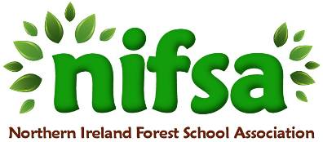

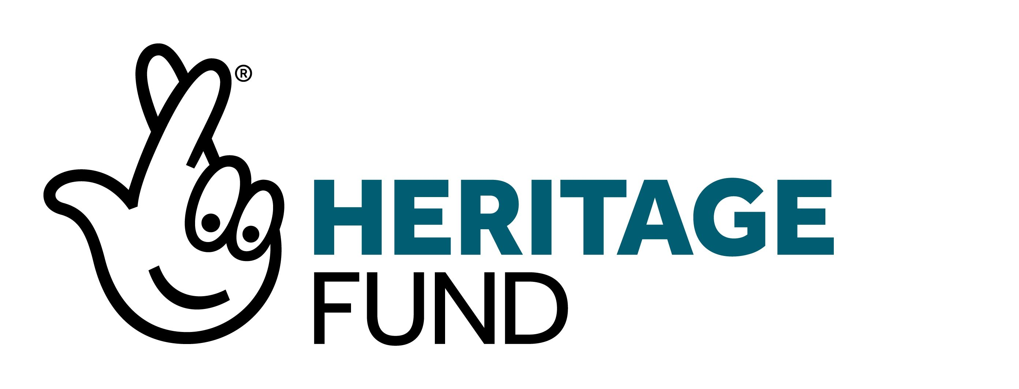
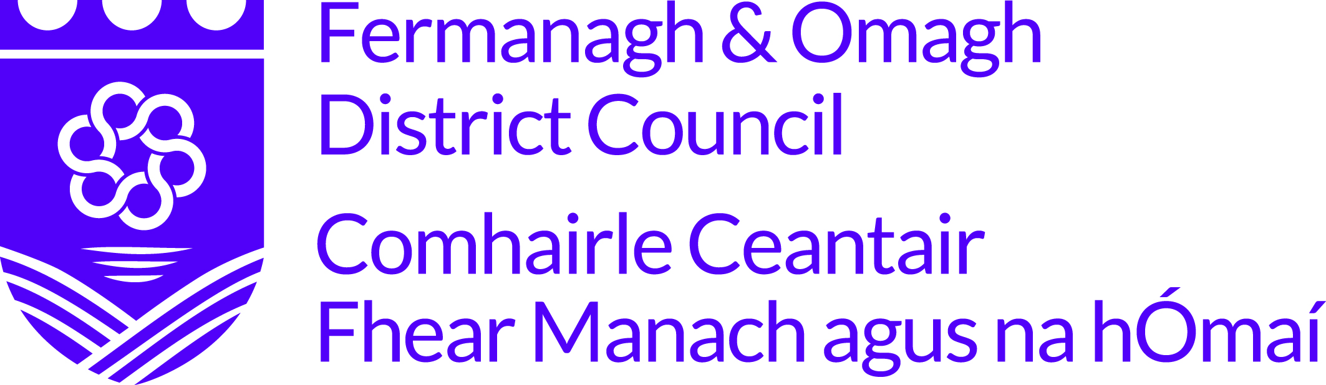

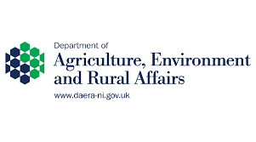

Closing date for applications: Friday 24th June 2022.

Please note: If you have received funding to complete the Forest Schools programme in the last 3 years, you are unfortunately not eligible to re-apply at this time.

Section 1: School Details
Name & Address of School/organisation

Contact name

Email Address

Phone Number

Local Council area

Section 2: Proposed Forest School site and project

- Name of proposed Forest School site (council park/open space/own school grounds/other)

- How do you propose to travel to the site if not on school grounds?

- Proposed group/age categories

- Estimated number of pupils/children/young people regularly attending the programme

- How would your organisation benefit from participation in the Forest School programme? Please outline how the group you have selected will benefit more than other groups/age categories (200 words).

- Will you encourage parents/other volunteers to take part in Forest School sessions/activities? If yes, how will you do this?
Please also outline how you will share and promote the benefits of outdoor learning (200 words).

- How do you plan to continue the Forest School programme in future years? (100 words)

Once you have completed your application form, save it in pdf format and send via email to biodiversity@fermanaghomagh.com
Reminder: closing date for applications is Friday 24th June 2022.

